DAA Practical 8 – BFS and DFS Graph Traversal
Design and Analysis of Algorithms

Aim
To implement Breadth First Search (BFS) and Depth First Search (DFS) for graph traversal.

BFS (Breadth First Search)

1. Algorithm
Algorithm: BFS (Breadth First Search)

Aim:
To visit all vertices of a graph level by level, starting from a given vertex.

Input:
- Graph (adjacency matrix / adjacency list)
- Starting vertex

Output:
- Order of visited vertices
- Time and space complexity

Steps:
1. Start
2. Create an empty queue
3. Create a visited array and mark all vertices as not visited
4. Insert the start vertex into the queue
5. Mark the start vertex as visited
6. Repeat steps 7 to 10 while queue is not empty
7. Remove one vertex from the front of the queue (call it node)
8. Print node
9. For every neighbour of node
10. If neighbour is not visited then
Insert neighbour into the queue
Mark neighbour as visited
11. Stop

Idea:
BFS uses a queue.
It first visits all neighbours of the current node,
then their neighbours, and so on (level by level).

Example Graph:
A -- B -- D
| |
C E
| |
F ----

Start from A
BFS order: A B C D E F

Time Complexity: O(V + E)
Space Complexity: O(V)

Where V = number of vertices, E = number of edges

2. Program Code (C Language)
File: Code/bfs.c
#include <stdio.h>

#define MAX 20

/*
BFS - Breadth First Search
Visit vertices level by level using a queue
Graph vertices: 0=A, 1=B, 2=C, 3=D, 4=E, 5=F
*/

int main()
{
// adjacency list for the graph
// A-B, A-C, B-D, B-E, C-F, E-F
int graph[6][6] = {
{0, 1, 1, 0, 0, 0}, // A connected to B, C
{1, 0, 0, 1, 1, 0}, // B connected to A, D, E
{1, 0, 0, 0, 0, 1}, // C connected to A, F
{0, 1, 0, 0, 0, 0}, // D connected to B
{0, 1, 0, 0, 0, 1}, // E connected to B, F
{0, 0, 1, 0, 1, 0} // F connected to C, E
};

char name[] = {'A', 'B', 'C', 'D', 'E', 'F'};
int visited[6] = {0, 0, 0, 0, 0, 0};

int queue[MAX];
int front = 0, rear = 0;
int start = 0; // start from A
int node, next;

printf("BFS Traversal:\n");

// put start node in queue and mark visited
queue[rear++] = start;
visited[start] = 1;

while (front < rear)
{
// take one node from front of queue
node = queue[front++];
printf("%c ", name[node]);

// add all unvisited neighbours to queue
for (next = 0; next < 6; next++)
{
if (graph[node][next] == 1 && visited[next] == 0)
{
queue[rear++] = next;
visited[next] = 1;
}
}
}

printf("\n");
printf("Time Complexity: O(V + E)\n");
printf("Space Complexity: O(V)\n");

return 0;
}

3. Output
Sample program output:
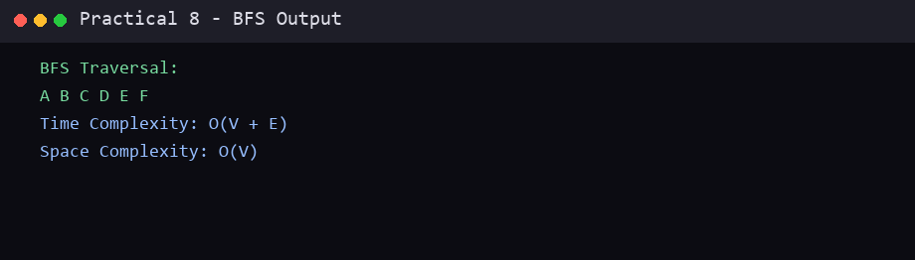

DFS (Depth First Search)

1. Algorithm
Algorithm: DFS (Depth First Search)

Aim:
To visit all vertices of a graph by going as deep as possible along one path,
then backtracking.

Input:
- Graph (adjacency matrix / adjacency list)
- Starting vertex

Output:
- Order of visited vertices
- Time and space complexity

Steps:
1. Start
2. Create a visited array and mark all vertices as not visited
3. Call DFS(start)
4. Stop

Procedure DFS(node):
1. Print node
2. Mark node as visited
3. For every neighbour of node
4. If neighbour is not visited then
Call DFS(neighbour)

Idea:
DFS uses recursion (or a stack).
It goes deep on one path first, then comes back (backtracks)
to explore the remaining paths.

Example Graph:
A -- B -- D
| |
C E
| |
F ----

Start from A
One possible DFS order: A B D E F C

Time Complexity: O(V + E)
Space Complexity: O(V)

Where V = number of vertices, E = number of edges

2. Program Code (C Language)
File: Code/dfs.c
#include <stdio.h>

/*
DFS - Depth First Search
Go deep along one path, then backtrack
Graph vertices: 0=A, 1=B, 2=C, 3=D, 4=E, 5=F
*/

int graph[6][6] = {
{0, 1, 1, 0, 0, 0}, // A connected to B, C
{1, 0, 0, 1, 1, 0}, // B connected to A, D, E
{1, 0, 0, 0, 0, 1}, // C connected to A, F
{0, 1, 0, 0, 0, 0}, // D connected to B
{0, 1, 0, 0, 0, 1}, // E connected to B, F
{0, 0, 1, 0, 1, 0} // F connected to C, E
};

char name[] = {'A', 'B', 'C', 'D', 'E', 'F'};
int visited[6] = {0, 0, 0, 0, 0, 0};

void dfs(int node)
{
int next;

// visit current node
printf("%c ", name[node]);
visited[node] = 1;

// visit all unvisited neighbours
for (next = 0; next < 6; next++)
{
if (graph[node][next] == 1 && visited[next] == 0)
dfs(next);
}
}

int main()
{
int start = 0; // start from A

printf("DFS Traversal:\n");
dfs(start);

printf("\n");
printf("Time Complexity: O(V + E)\n");
printf("Space Complexity: O(V)\n");

return 0;
}

3. Output
Sample program output:
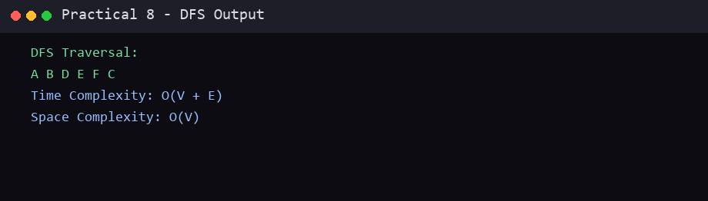

Conclusion
In this practical, the required algorithm(s) were studied and implemented successfully in C. The algorithm, program code and sample output are recorded above. This practical helped in understanding the working, advantages and complexity of the technique(s) used.
End of Practical 8

